# CS 255 System Design Document – Aaron Boykin

This template lays out all the different sections that you need to complete for Project Two. Each section has guidance to prompt your thinking. You will need to continually reference the interview transcript as you work to make sure that you are addressing your client’s needs. There is no required length for the final document. Instead the goal is to complete each section based on what your client’s needs are. Remove this note when you are finished, and replace all bracketed text with the relevant information.

## UML Diagrams

### UML Use Case Diagram

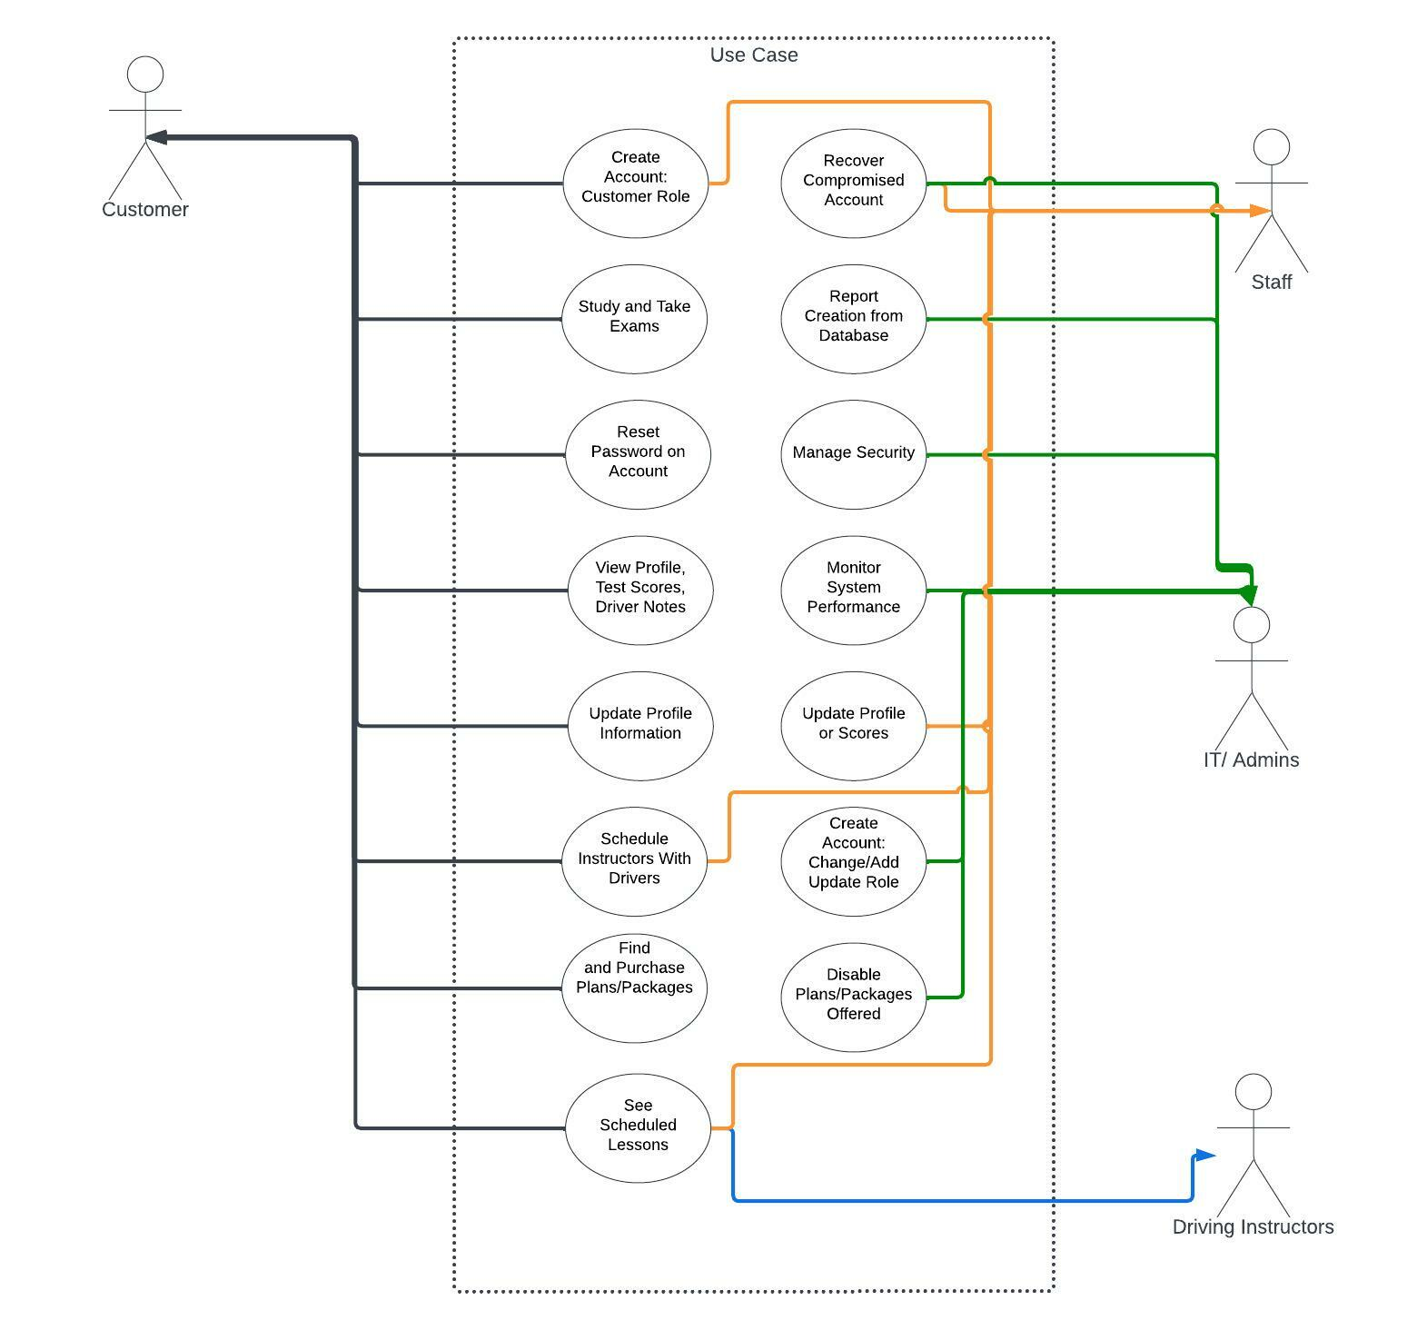

### UML Activity Diagram

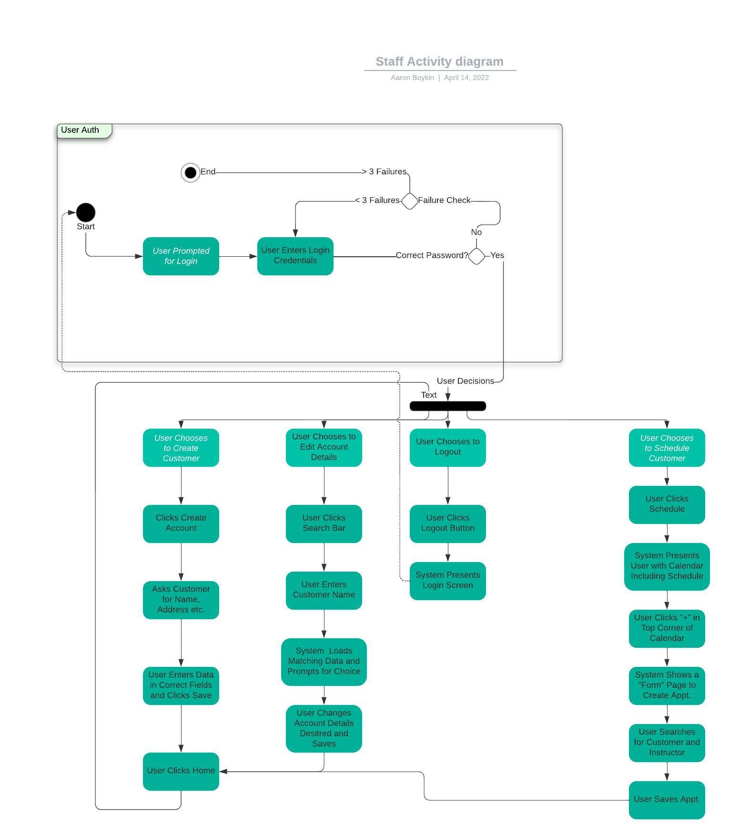

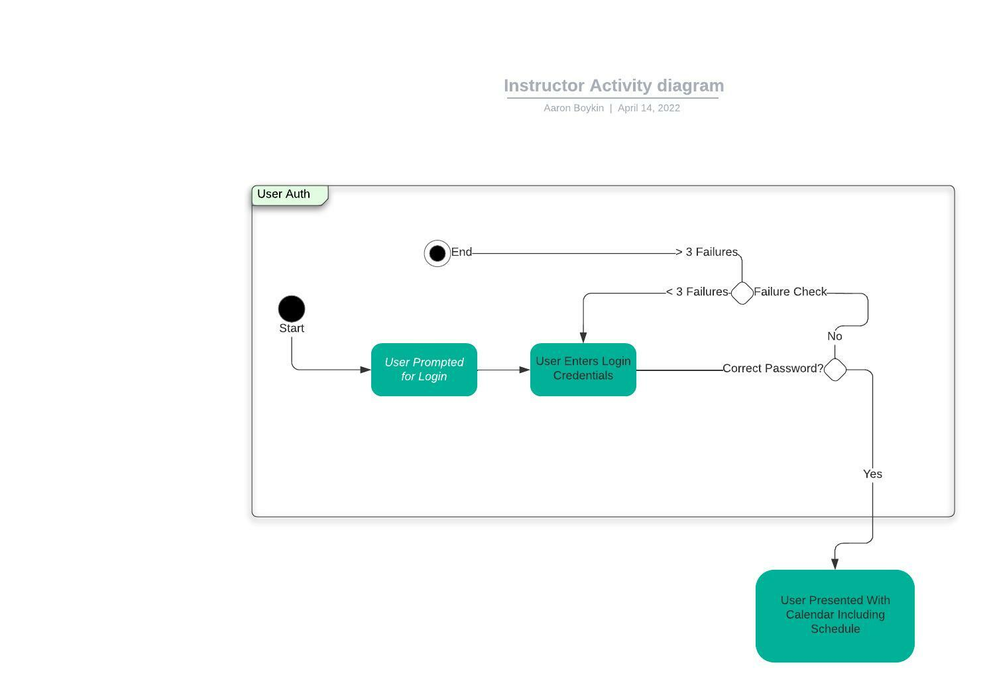

### UML Sequence Diagram

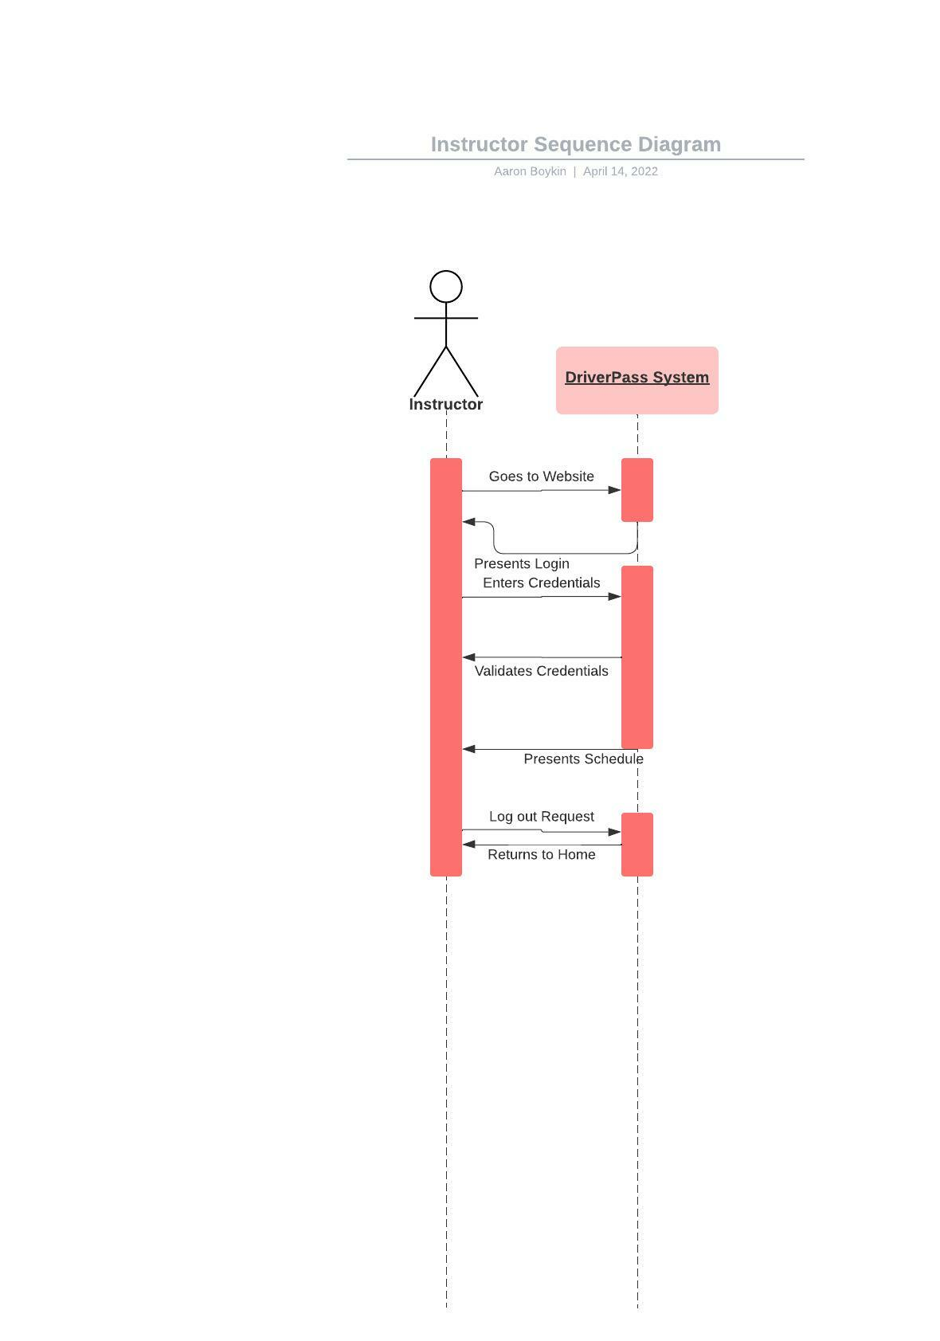

### UML Class Diagram

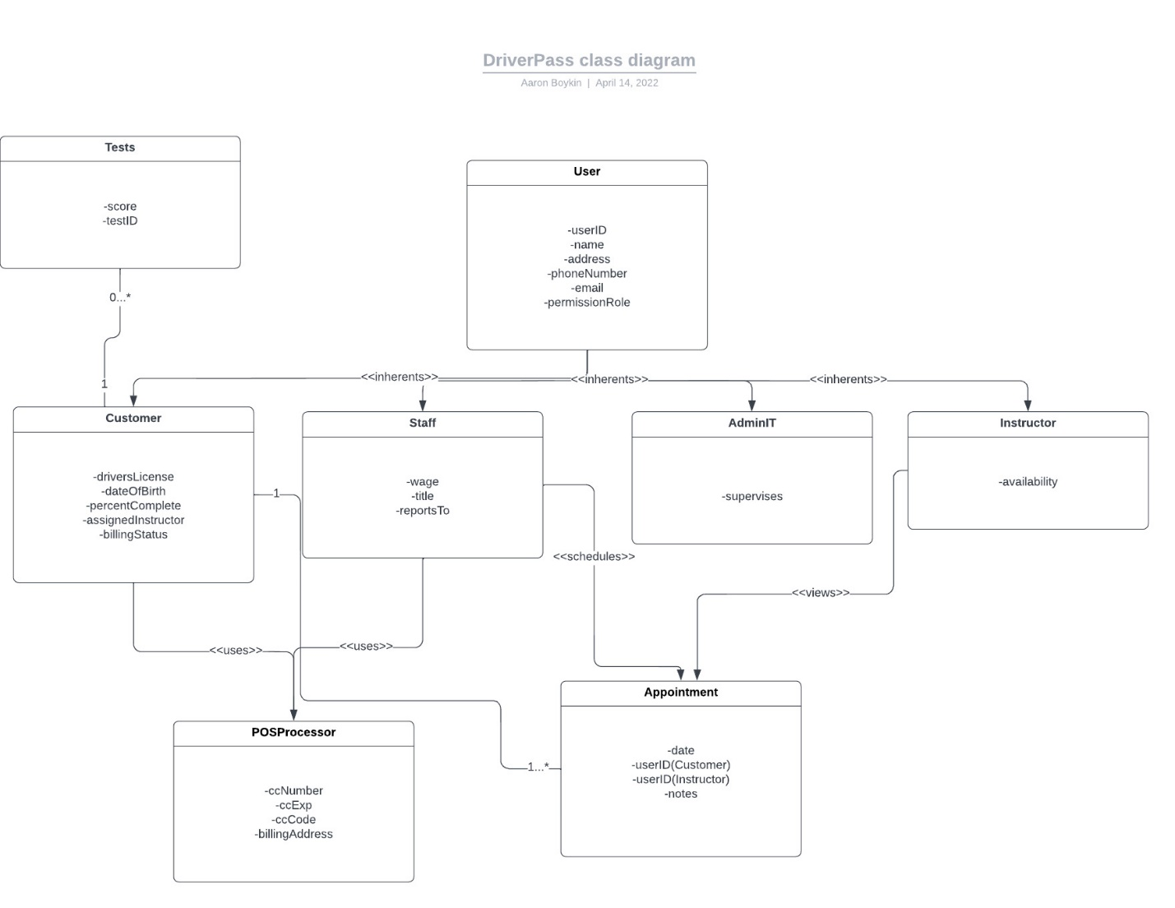

## Technical Requirements

For the end user, this will have minimum requirements as it should operate on all modern web browsers. Any computer capable of running the latest version of Windows, and latest 4 version of macOS, or any up-to-date Linux OS can run this with an updated web browser. Hardware wise, this would equate to 4GB RAM, 40GB or more of free storage, a processor made in the last 7-10 years, and minimal graphics card. It will also be available to all mobile users that have a phone made in the last 7 years (4 years for android phones).

For the server running this, I would suggest using cloud-based computing so that it can grow effortlessly with the company. It is lower initial investment, more reliable in most cases and less stress on IT department. The amount of data that could be collected over time as this grows could become substantial and that is where cloud-based servers will shine.